**AGENT - Adwerx Cheatsheet**  (Internal Use ONLY)

**Adwerx Listing Ads**

**Description:** What we offer now free for any listing $200K and up (subject to change) for 4 weeks. Comes with a FREE retargeting ad for anyone who clicks on the ad. Seller receives an analytics report and agent has access to analytics via dashboard. Demographics of viewers of ad include individuals actively looking to move/buy a home in your area. Once someone clicks on the link on the ad they are taken to the agent’s Lang website.

**ONLY for new active listing status**. Will go live after 24 hrs of new listing hitting MLS. Only for residential properties.

**Duration:** currently 4 weeks (subject to change)

**Video Explanation:** <https://www.youtube.com/watch?v=IEvQ92VrPXU>

**Pricing to extend your campaign**: Lang’s Preferred pricing is discounted at $50/week to add duration to the ad.

**Adwerx Buyer’s Side/”Just Sold” Ads**

**Description:** What we offer now free for any just sold property where the LANG AGENT represented the buyer in the transaction. No minimum amount for this campaign (subject to change).

**Duration:** currently 1 week (subject to change)

**ONLY for newly just sold/closed status where the agent is buying agent**. Will go live after 24 hrs of new listing hitting MLS. Only for residential properties.

**Video Explanation:** this is a new feature, no video exists.

**Pricing to extend your campaign**: Lang’s Preferred pricing is discounted at $50/week to add duration to the ad.

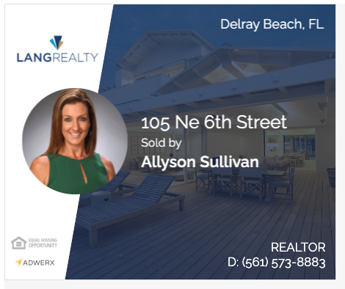

Example of “JUST SOLD AD”

**Customer Support:**

Phone: 888.746.5678

Account dashboards: <https://langrealty.adwerx.com/>

Email: [support@adwerx.com](mailto:support@adwerx.com)

Enter Seller’s email in your listing so the seller can receive daily reporting of where their listing ad was showcased (only use on listing ads). See example of report below:

